TASK 3:

* Create an Ubuntu Virtual Machine.
* Install the Apache2 service on it.
* Make the website publicly accessible.

Steps to create Ubuntu virtual machine, then, install Apache2 service on it and make it publicly accessible.

Step 1: Open Virtual Machine service inside Azure Portal and fill all the details make sure to select Ubuntu server while selecting Image.

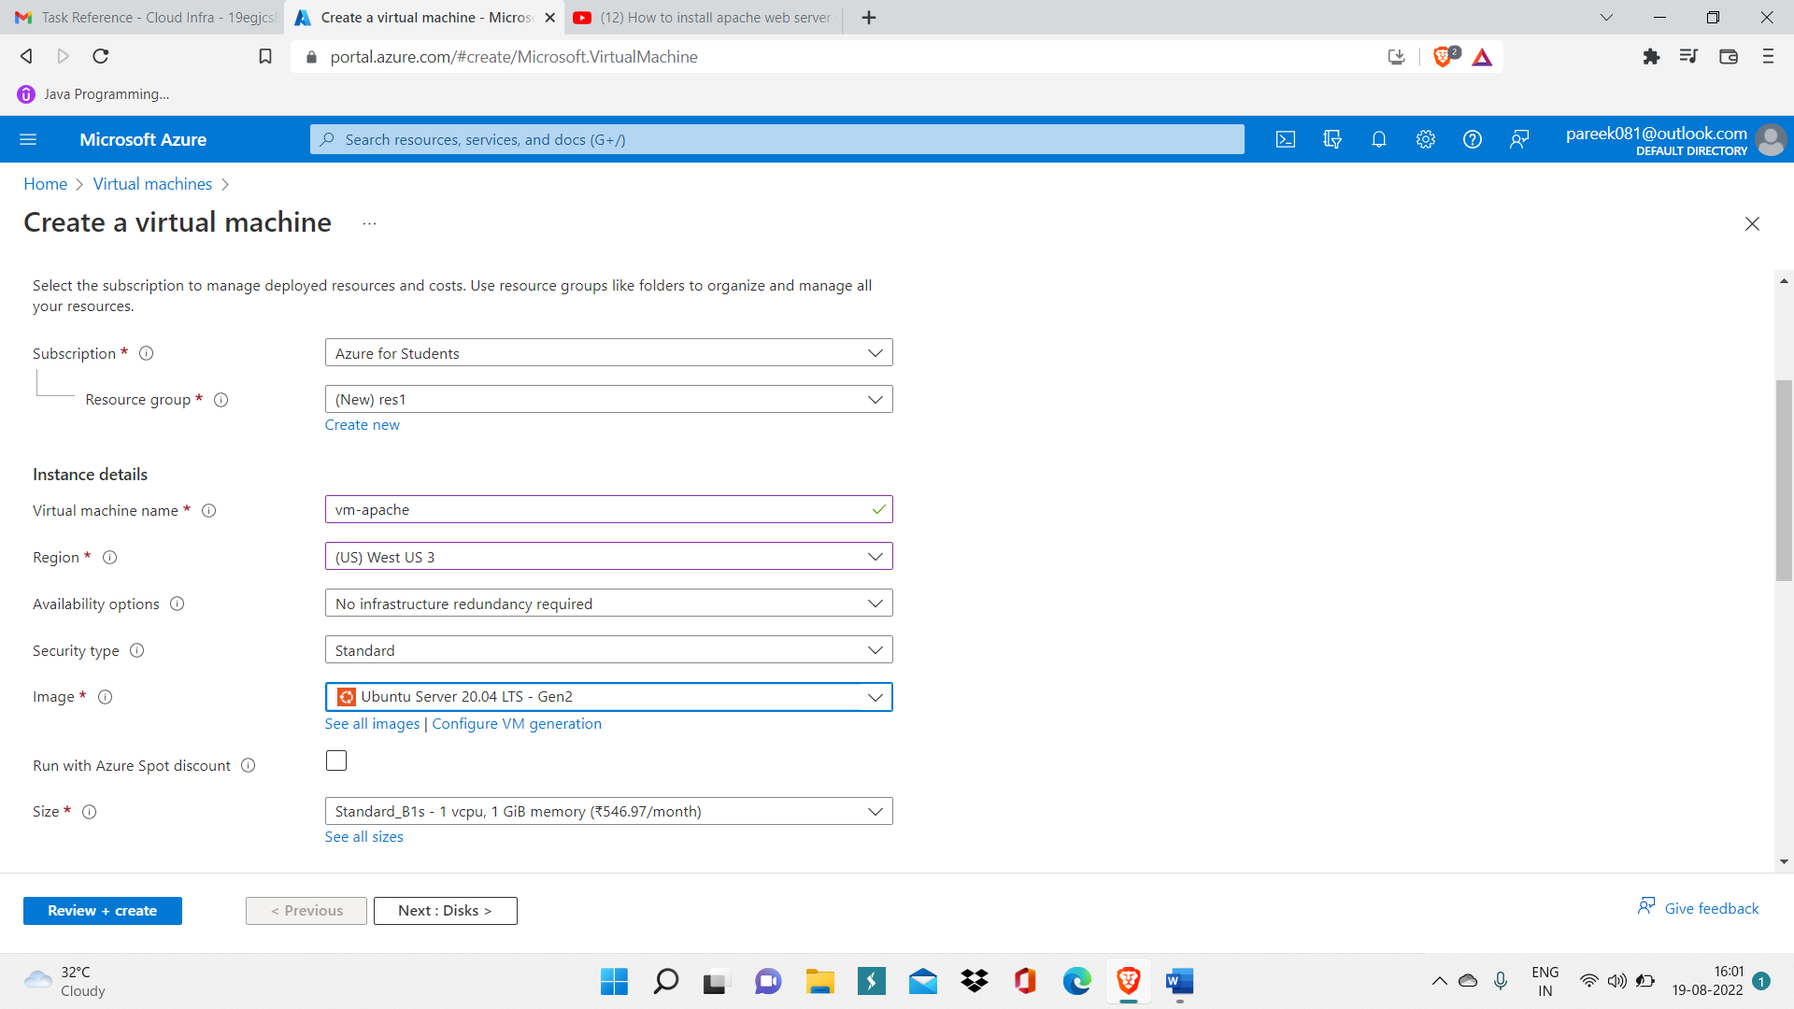

Step 2: Now after VM is deployed, go inside overview of VM.

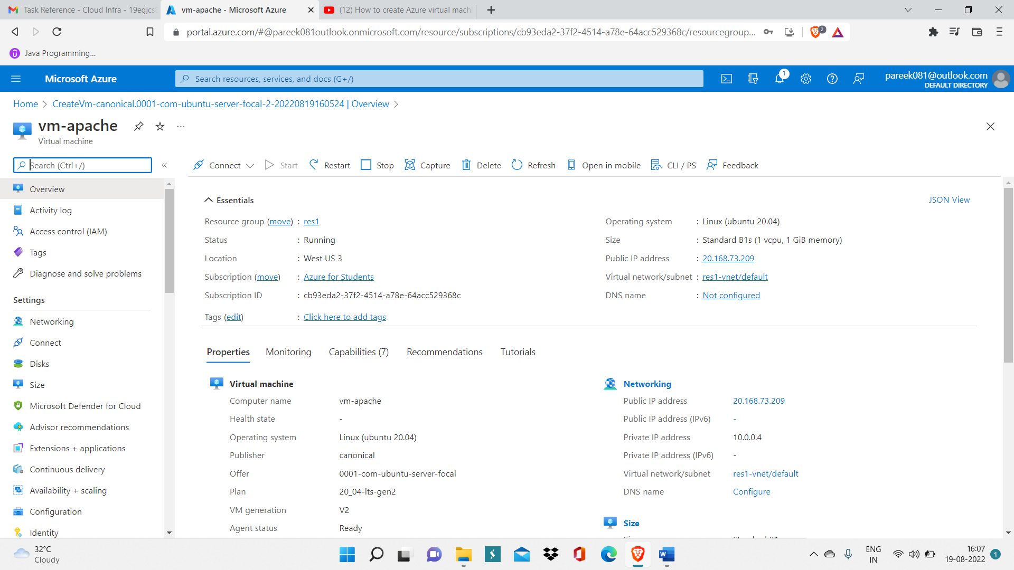

Step 3: Now open Cloud shell window, you can find cloud shell inside navbar.

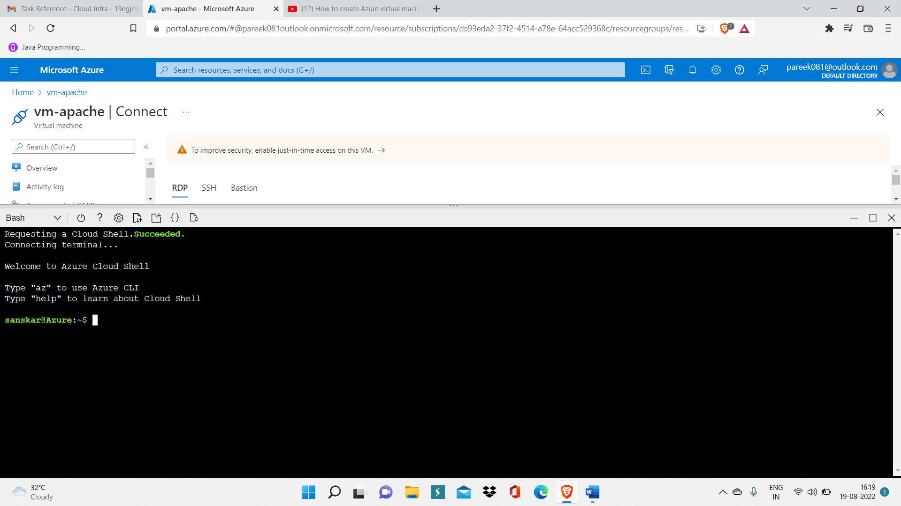

Step 4: Now write command ‘ssh <username>@<public IP address of VM> ‘ to access VM. After this, you will get access to your VM.

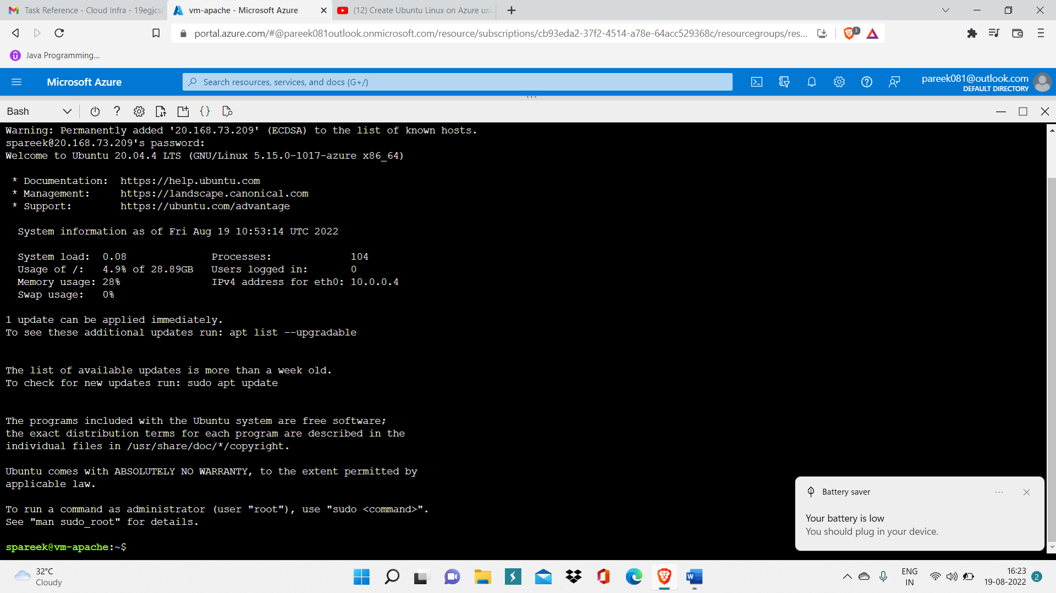

Step 5: Now write command ‘sudo apt update’ This command is used to download package information from all configured sources.

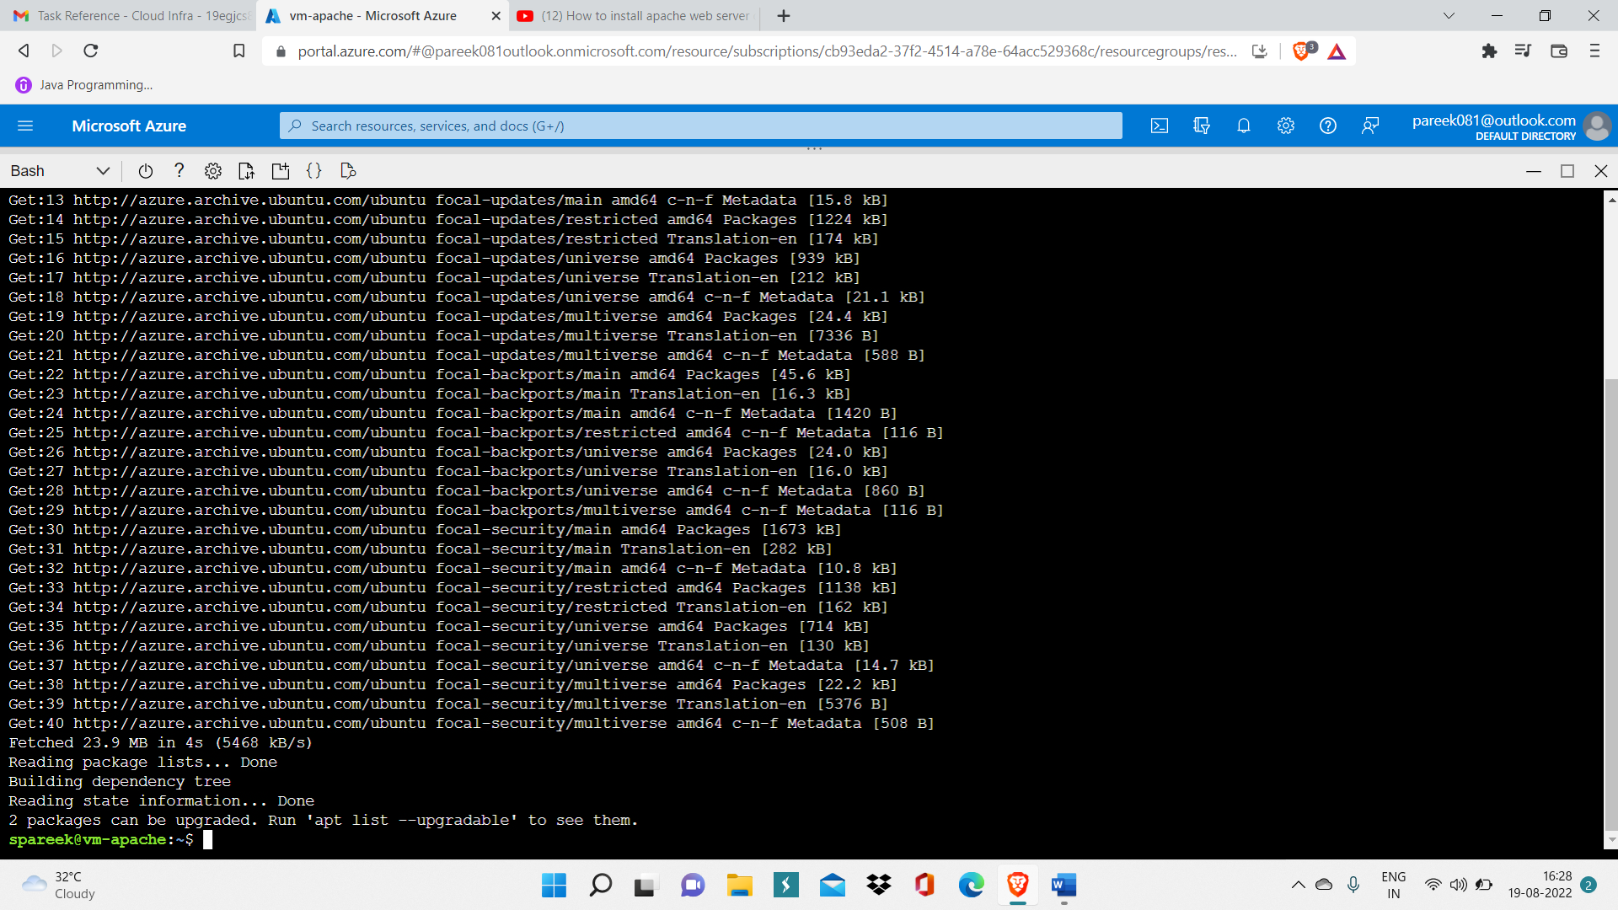

Step 6: Now write command ‘sudo apt-cache search apache2’ to check whether apache2 service package is present or not.

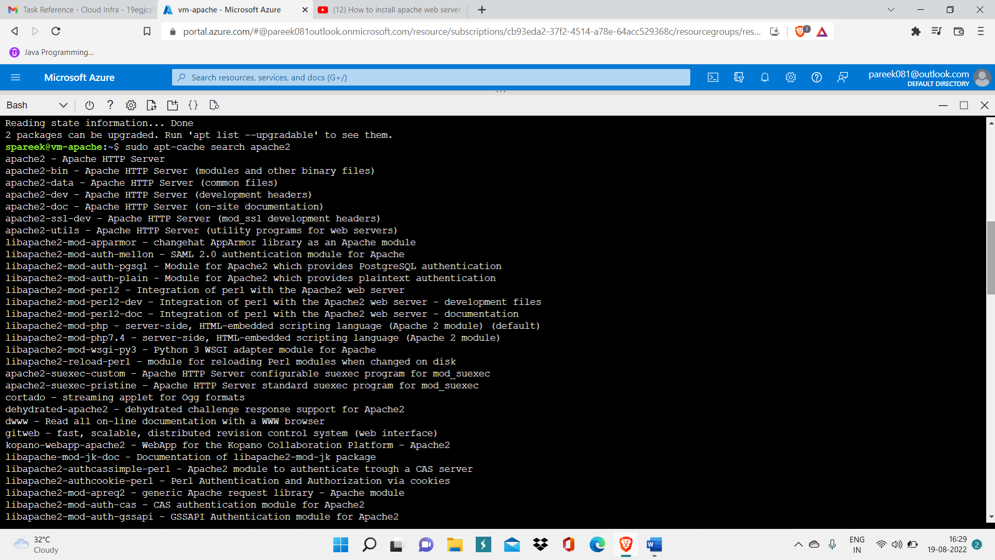

Step 7: Now write command ‘sudo apt-get install apache2’ to install apache2 inside your Ubuntu VM.

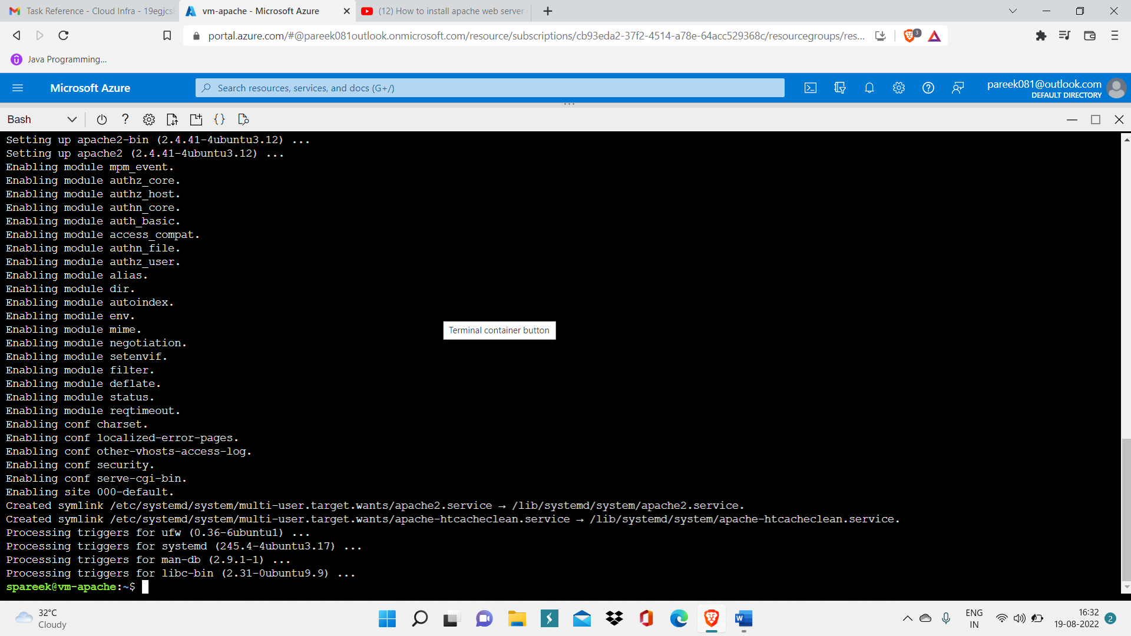

Now, your Apache2 is successfully installed inside your VM.

Step 8: To make website publicly accessible write command ‘sudo ufw allow 80/tcp’.

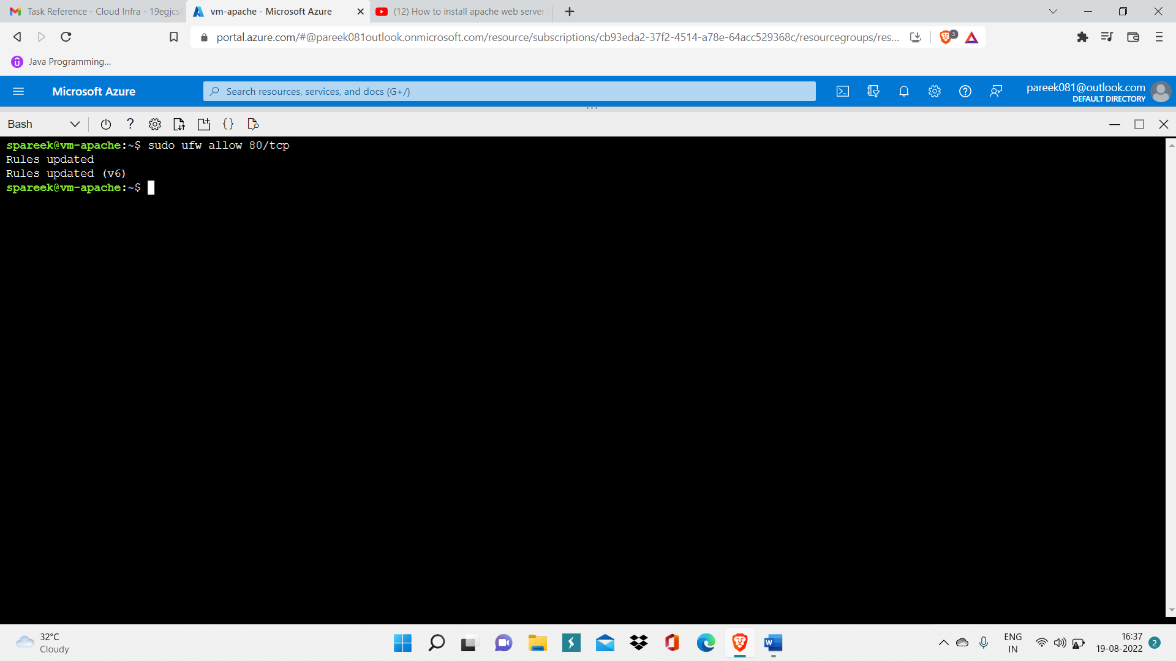

Step 9: Now to check if it is publicly accessible or not, write public IP of your VM inside web browser and click Enter.

This shows website is publicly accessible.

